COMPUTER NETWORKS

UNIT – 1

1. What is a computer network? Brief on any 4 networking devices.

* **Computer Network** is a collection of autonomous computers interconnected by a single technology.
* The aim of the computer network is the sharing of resources among various devices.
* In the case of computer network technology, there are several types of networks that vary from simple to complex level.

The four networking devices are:

### Hub:

### Hub is a central device that splits the network connection into multiple devices. When computer requests for information from a computer, it sends the request to the Hub. Hub distributes this request to all the interconnected computers.

1. Switch:

A switch is a multiport bridge with a buffer and a design that can boost its efficiency (a large number of ports imply less traffic) and performance. A switch is a data link layer device. The switch can perform error checking before forwarding data, that makes it very efficient as it does not forward packets that have errors and forward good packets selectively to correct port only.

1. Router:

A router is a network layer hardware device that transmits data from one LAN to another if both networks support the same set of protocols. So a router is connected to at least two LANs and the internetserviceprovider (ISP). It receives its data in the form of packets, which are dataframes with their destinationaddress added.

1. Modem:

Modem is a device that enables a computer to send or receive data over telephone or cable lines. The data stored on the computer is digital whereas a telephone line or cable wire can transmit only analog data.

1. Explain in brief the classification of computer networks?

A computer network is a group of computers linked to each other that enables the computer to communicate with another computer and share their resources, data, and applications.

A computer network can be categorized by their size. A **computer network** is mainly of **four types**:

* LAN (Local Area Network)
* PAN (Personal Area Network)
* MAN (Metropolitan Area Network)
* WAN (Wide Area Network)
* **LAN (Local Area Network):**
* Local Area Network is a group of computers connected to each other in a small area such as building, office.
* LAN is used for connecting two or more personal computers through a communication medium such as twisted pair, coaxial cable, etc.
* It is less costly as it is built with inexpensive hardware such as hubs, network adapters, and ethernet cables.
* The data is transferred at an extremely faster rate in Local Area Network.
* Local Area Network provides higher security.

Advantage:

1. Local Area Network offers the facility to share a single internet connection among all the LAN users. 2. Data of all network users can be stored on a single hard disk of the server computer.

Disadvantages:

1. The LAN admin can check personal data files of every LAN user, so it does not offer good privacy.

2. Unauthorized users can access critical data of an organization in case LAN admin is not able to secure centralized data repository.

* **PAN (Personal Area Computer):**
* It is mostly personal devices network equipped within a limited area.
* Allows you to handle the interconnection of IT devices at the surrounding of a single user.
* PAN includes mobile devices, tablet, and laptop.
* It can be wirelessly connected to the internet called WPAN.
* Appliances use for PAN: cordless mice, keyboards, and Bluetooth systems.

Advantages:

1. PAN networks are relatively secure and safe
2. It offers only short-range solution up to ten meters
3. Strictly restricted to a small area

Disadvantage:

1. It may establish a bad connection to other networks at the same radio bands.
2. Distance limits.

* **MAN (Metropolitan Area Network):**
* It mostly covers towns and cities in a maximum 50 km range
* Mostly used medium is optical fibers, cables
* A metropolitan area network is a network that covers a larger geographic area by interconnecting a different LAN to form a larger network.
* Government agencies use MAN to connect to the citizens and private industries.
* In MAN, various LANs are connected to each other through a telephone exchange line.
* It has a higher range than Local Area Network (LAN).

Advantage:

1. The dual bus in MAN network provides support to transmit data in both directions concurrently.
2. A MAN network mostly includes some areas of a city or an entire city.

Disadvantage:

1. You need more cable to establish MAN connection from one place to another.
2. In MAN network it is tough to make the system secure from hackers

* **WAN (Wide Area Network):**
* The software files will be shared among all the users; therefore, all can access to the latest files.
* Any organization can form its global integrated network using WAN.
* A Wide Area Network is not limited to a single location, but it spans over a large geographical area through a telephone line, fiber optic cable or satellite links.
* The internet is one of the biggest WAN in the world.
* A Wide Area Network is widely used in the field of Business, government, and education.

Advantage:

1. Contains devices like mobile phones, laptop, tablet, computers, gaming consoles, etc.
2. WLAN connections work using radio transmitters and receivers built into client devices.

Disadvantage:

1. The initial setup cost of investment is very high
2. Offers lower security compared to other types of networks.
3. It is difficult to maintain the WAN network. You need skilled technicians and network administrators.

3. What is network protocol stack? Explain with a diagram.

A **protocol** is simply defined as a set of rules and regulations for data communication. Rules are basically defined for each and every step and process at time of communication among two or more computers. Networks are needed to follow these protocols to transmit data successfully. All protocols might be implemented using hardware, software, or combination of both of them. There are three aspects of protocols given below :

* **Syntax –**  
  It is used to explain data format that is needed to be sent or received.
* **Semantics –**  
  It is used to explain exact meaning of each of sections of bits that are usually transferred.
* **Timings –**  
  It is used to explain exact time at which data is generally transferred along with speed at which it is transferred.
* **Protocol Hierarchies :**  
  Generally, Computer networks are comprised of or contain a large number of pieces of hardware and software. To just simplify network design, various networks are organized and arranged as a stack of layers of hardware and software, one on top of another. The number, name, content, and function of each layer might vary and can be different from one network to another. The main purpose of each of layers is just to offer and provide services to higher layers that are present. Each and every layer has some particular task or function. In programming, this concept is very common. The networks are organized and arranged as different layers or levels simply to reduce and minimize complexity of design of network software.

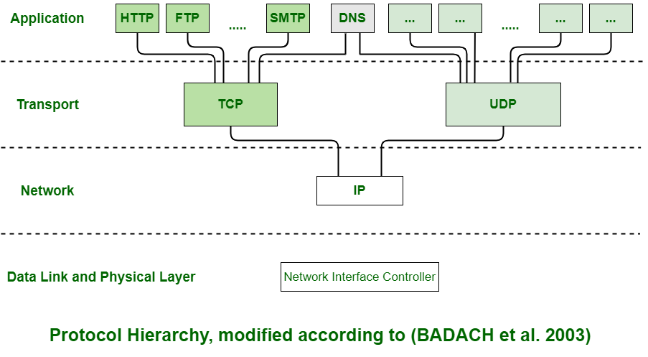

4. What are the uses of computer networks?

* **Resource sharing:** Resource sharing is the sharing of resources such as programs, printers, and data among the users on the network without the requirement of the physical location of the resource and user.
* **Server-Client model:** Computer networking is used in the **server-client model**. A server is a central computer used to store the information and maintained by the system administrator. Clients are the machines used to access the information stored in the server remotely.
* **Communication medium:** Computer network behaves as a communication medium among the users. For example, a company contains more than one computer has an email system which the employees use for daily communication.
* **E-commerce:** Computer network is also important in businesses. We can do the business over the internet. For example, amazon.com is doing their business over the internet, i.e., they are doing their business over the inter

**5.** Write any four applications of computer networks.

Four application are:

**1.Business Application:**

a. Resources Sharing.

b. Server-Client Model.

c. Communication Medium.

d. e-commerce.

**2. Home Application:**

some of the most important uses of the Internet for home users are as follows:

* Access to remote information
* Person-to-person communication
* Interactive entertainment
* Electronic commerce

**3. Mobile Users:**

Mobile computers, such as notebook computers and Mobile phones, is one of the fastest-growing segment of the entire computer industry. Although wireless networking and mobile computing are often related, they are not identical, as the below figure shows.

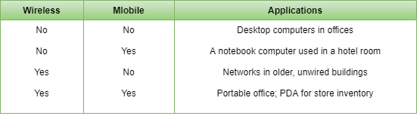

6. Explain OSI/ISO reference model with a neat diagram.

* OSI stands for **Open System Interconnection** is a reference model that describes how information from a [software](https://www.javatpoint.com/software) application in one [computer](https://www.javatpoint.com/what-is-computer) moves through a physical medium to the software application in another computer.
* OSI consists of seven layers, and each layer performs a particular network function.
* OSI model was developed by the International Organization for Standardization (ISO) in 1984, and it is now considered as an architectural model for the inter-computer communications.
* OSI model divides the whole task into seven smaller and manageable tasks. Each layer is assigned a particular task.
* Each layer is self-contained, so that task assigned to each layer can be performed independently.

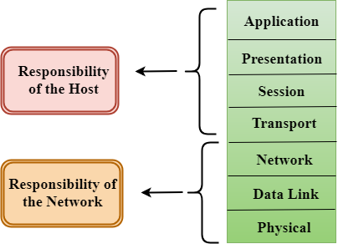

* The OSI model is divided into two layers: upper layers and lower layers.
* The upper layer of the OSI model mainly deals with the application related issues, and they are implemented only in the software. The application layer is closest to the end user. Both the end user and the application layer interact with the software applications. An upper layer refers to the layer just above another layer.
* The lower layer of the OSI model deals with the data transport issues. The data link layer and the physical layer are implemented in hardware and software. The physical layer is the lowest layer of the OSI model and is closest to the physical medium. The physical layer is mainly responsible for placing the information on the physical medium.

## **Functions of the OSI Layers**

There are the seven OSI layers. Each layer has different functions. A list of seven layers are given below:

1. Physical Layer
2. Data-Link Layer
3. Network Layer
4. Transport Layer
5. Session Layer
6. Presentation Layer
7. Application Layer

1. Physical Layer:

* The main functionality of the physical layer is to transmit the individual bits from one node to another node.
* It is the lowest layer of the OSI model.
* It establishes, maintains and deactivates the physical connection.

2. Data-Link Layer:

* This layer is responsible for the error-free transfer of data frames.
* It defines the format of the data on the network.
* It provides a reliable and efficient communication between two or more devices.
* It is mainly responsible for the unique identification of each device that resides on a local network.
* It contains two sub-layers:

3. Network Layer:

* It is a layer 3 that manages device addressing, tracks the location of devices on the network.
* It determines the best path to move data from source to the destination based on the network conditions, the priority of service, and other factors.
* The Data link layer is responsible for routing and forwarding the packets.

4. Transport Layer:

* The Transport layer is a Layer 4 ensures that messages are transmitted in the order in which they are sent and there is no duplication of data.
* The main responsibility of the transport layer is to transfer the data completely.
* It receives the data from the upper layer and converts them into smaller units known as segments.
* This layer can be termed as an end-to-end layer as it provides a point-to-point connection between source and destination to deliver the data reliably.

5. Session Layer:

* It is a layer 3 in the OSI model.
* The Session layer is used to establish, maintain and synchronizes the interaction between communicating devices.

6. Presentation Layer:

* A Presentation layer is mainly concerned with the syntax and semantics of the information exchanged between the two systems.
* It acts as a data translator for a network.
* This layer is a part of the operating system that converts the data from one presentation format to another format.
* The Presentation layer is also known as the syntax layer.

7. Application Layer:

* An application layer serves as a window for users and application processes to access network service.
* It handles issues such as network transparency, resource allocation, etc.
* An application layer is not an application, but it performs the application layer functions.
* This layer provides the network services to the end-users.